**Module 5 Critical Thinking: Option 1**

Andrew Barnes

Colorado State University Global

CSC320-1

Dr. Schwartz

9/17/2023

**Pseudo Code**

1. Set up Scanner
2. Define array named weekdays with days of the week
3. Define an array named temperatures with temperatures.
4. For each weekday in the weekdays array
   1. Add the weekday to daysOfWeek.
   2. Add the temperature to dailyTemperatures.
5. While true (infinite loop)
   1. Ask the user to enter a day of the week or "week" for the whole week's temps.
   2. Read user input.
   3. If user input is "week" (case-insensitive)
      1. Call function for weekly average temperature.
      2. Display weekly average.
      3. For each day in the daysOfWeek ArrayList
         1. Display the day and temperature.
   4. Else if input matches any of days in the daysOfWeek ArrayList
      1. Find index of input day in daysOfWeek.
      2. Retrieve temperature for that day.
      3. Display input day and its temperature.
   5. Else
      1. Inform user that the input is invalid.
   6. Define a function to calculate the weekly average temperature:
      1. Initialize totalTemperature to 0.0.
      2. For temperature in dailyTemperatures
      3. Add temperature to totalTemperature
      4. Calculate average by dividing totalTemperature by the size of dailyTemperatures
      5. Return calculated average.

**Source Code**

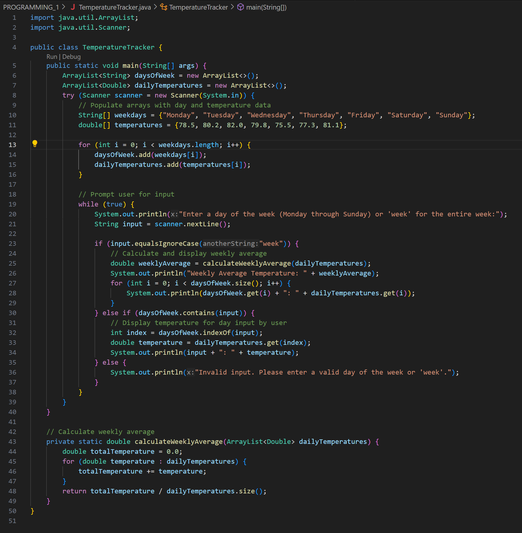

**Executing the Application**

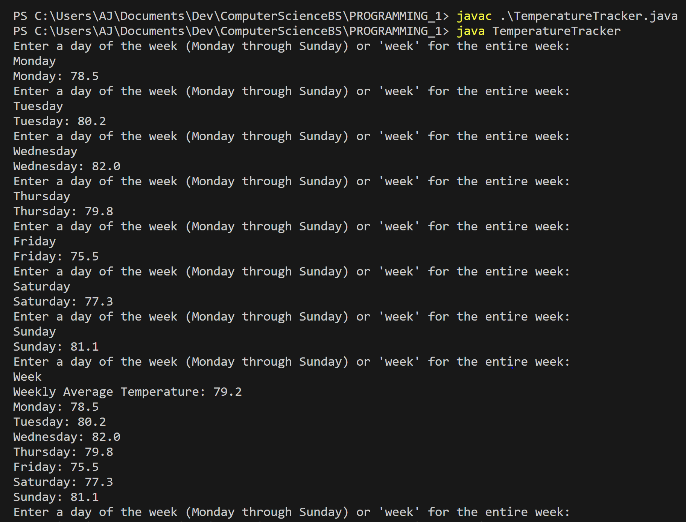

**Git Repository**

**Git Status**

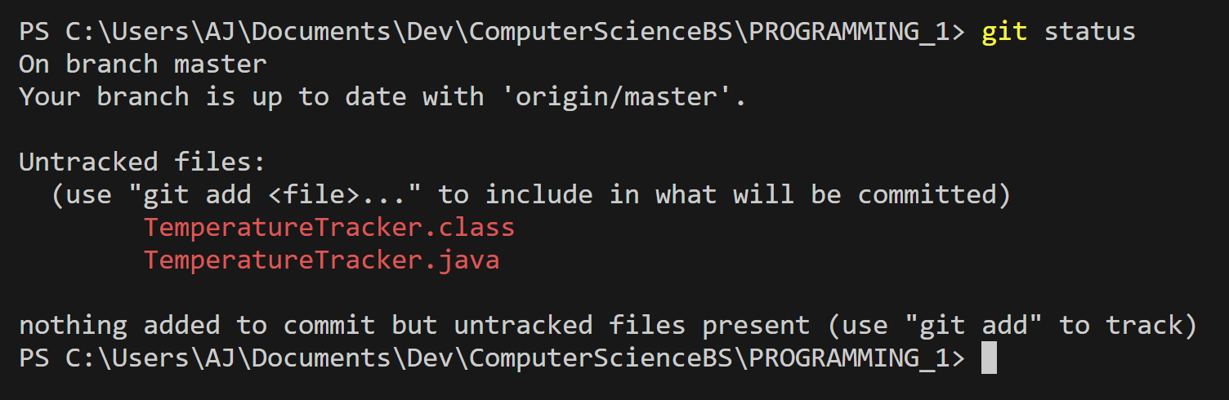

**Git Add**

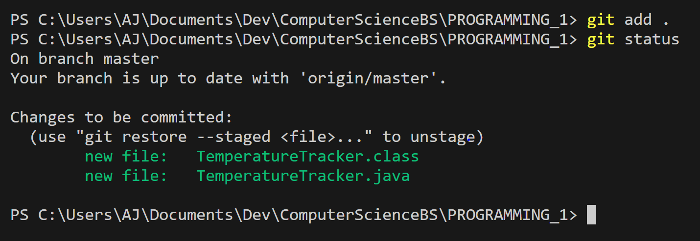

**Git Commit**

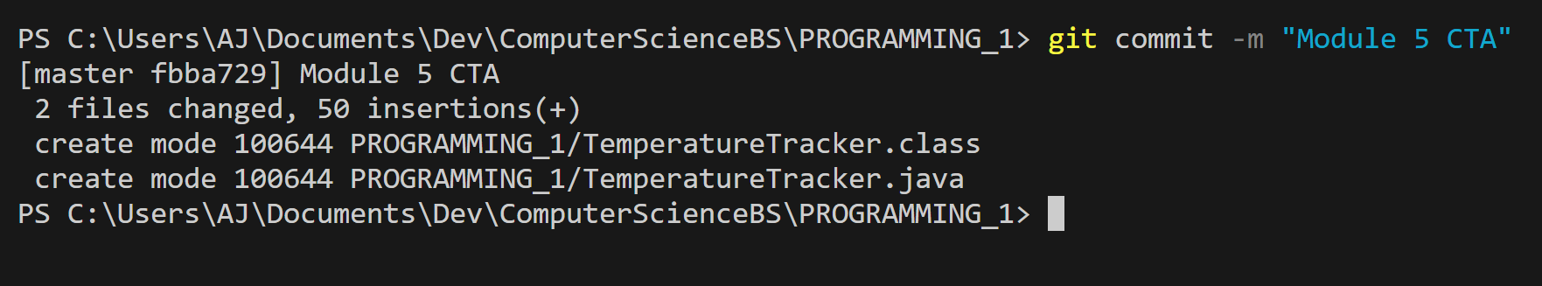

**Git Push**

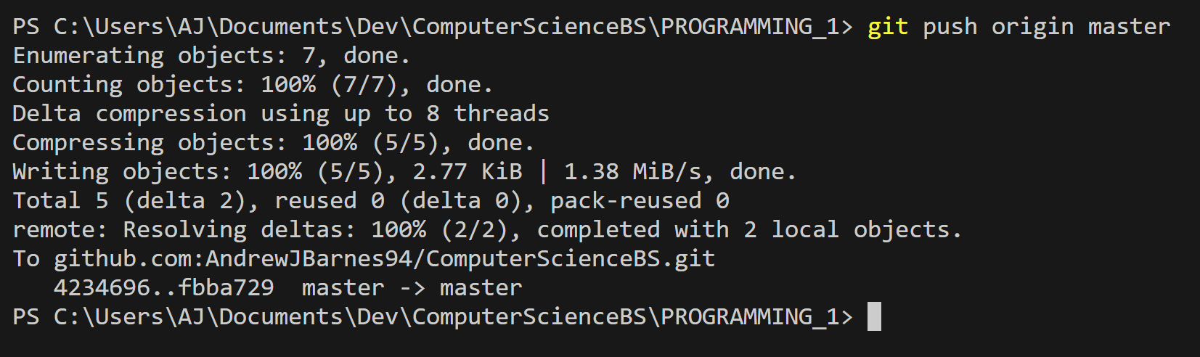

**GitHub Repository**

[**ComputerScienceBS/PROGRAMMING_1/TemperatureTracker.java at master · AndrewJBarnes94/ComputerScienceBS (github.com)**](https://github.com/AndrewJBarnes94/ComputerScienceBS/blob/master/PROGRAMMING_1/TemperatureTracker.java)